Bring an Edu-Taining Assembly to Your School!

Abra-Kid-Abra is please to donate an assembly to your school! Below are the character and educational programs we offer. We look forward to presenting one of these to your students!
Heroes Not Bullies
Winners Aren’t Users
Horoes Not Bullies
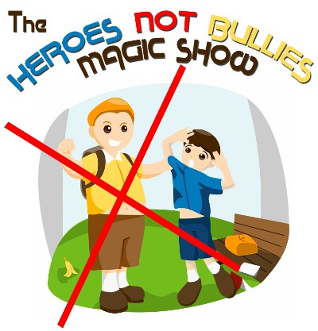
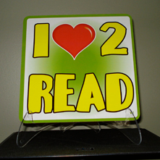

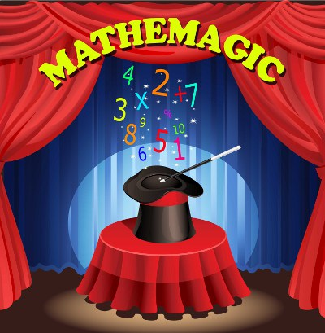
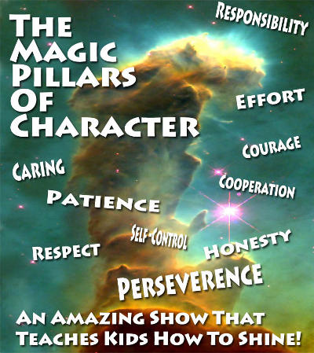

Fizz Boom Seuss
Mathemagic
Pillars of Character
The Magic of Reading
Abra-Kid-Abra 314-961-6912 www.abrakid.com


